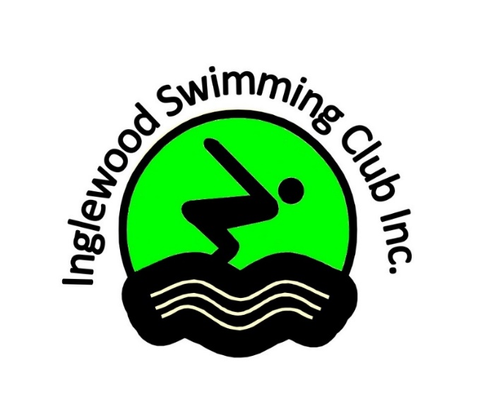
In association with DDRSA, Inglewood Swimming Club invites you to our:
Inglewood Swim Meet

Sunday 11th
January 2026
Gates open 7.45am
Warm Up: 8:00am-8.45am
Racing Start: 9:00am

Nominations: $7.50 per Event - Admission Free -
Nominations Close: Wednesday 7th January 2026- No late nominations accepted
All nominations are to be entered online in swim central
All events will be seeded into heats on nominated times
Participation medals will be awarded to 7yrs & under competitors
Medallions will be awarded to the first three placings in the:
8yrs, 9yrs, 10yrs, 11yrs, 12yrs 13yrs 14yrs and 15 & O 50m events.
10yrs,11yrs,12yrs,13yrs,14yrs and 15 & O 100m events.
11-12 yrs and 13 and Over 200m events

Age Champion awards will be awarded to Age Champions- Swimmer with the most overall points will be awarded Age Champion.!!! Must compete in all 50m events to eligible !!!

Fina rules will apply in all events, in case of dispute the referee’s decision will be final
Multi-class swimmers are welcome, please present your classification card to the referee
Clubs will be required to provide timekeepers on the day
BBQ & Canteen will be available during the day

For more information please contact: Adam 0434522225 or Naomi 0429519353
Email: inglewoodswimmingclub@gmail.com

Boys | Girls | Age | Event
1 | 1 | 7 & Under | 25m butterfly
2 | 3 | 10- 12 Years | 100m butterfly
4 | 5 | 13 & Over | 100m butterfly
6 | 7 | 8 & Over Multiclass | 50m butterfly
8 | 9 | 8 – 12 Years | 50m butterfly
10 | 11 | 13 & Over | 50m butterfly
12 | 12 | 7 & Under | 25m Breaststroke
13 | 14 | 10 - 12 Years | 100m Breaststroke
15 | 16 | 13 & Over | 100m Breaststroke
17 | 18 | 8 & Over multiclass | 50m Breaststroke
19 | 20 | 8 – 12 Years | 50m Breaststroke
21 | 22 | 13 & Over | 50m Breaststroke
23 | 24 | 10 Years | 100m I.M
25 | 26 | 11 & Over | 200m I.M
27 | 27 | 7 & Under | 25m Backstroke
28 | 29 | 10– 12 Years | 100m Backstroke
30 | 31 | 13 & Over | 100m Backstroke
32 | 33 | 8 & Over Multiclass | 50m Backstroke
34 | 35 | 8 – 12 Years | 50m Backstroke
36 | 37 | 13 & Over | 50m Backstroke
38 | 38 | 7 & Under | 25m freestyle
39 | 40 | 10– 12 Years | 100m freestyle
41 | 42 | 13 & Over | 100m freestyle
43 | 44 | 8 & Over Multiclass | 50m Freestyle
45 | 46 | 8 – 12 Years | 50m freestyle
47 | 48 | 13 & Over | 50m freestyle

Swim Hard, Dream Big

